[](https://www.iiuc.ac.bd/)

**Assignment**

**Assignment No. – 01**

**Submission date- 09 February, 2022**

**Course Title- DBMS (Lab)**

**Course Code: CSE-2424**

Submited to-

**Mr. Mohammad Aman Ullah**

**Assistant Professor**

01815641524

ullah047@yahoo.com, aman_cse@iiuc.ac.bd

Submitted by-

**MD. SOROWAR MAHABUB RABBY**

Matric ID: ***C201032*,** Section: ***4AM* ,** Semester**: *4th***

**Department of CSE (***Computer Science and Engineering***), IIUC**

**Cell:** *01834756433, 01521564157,* [*c201032@ugrad.iiuc.ac.bd*](mailto:c201032@ugrad.iiuc.ac.bd)

**Part 1**

**Test your knowledge:**

1.Initiate an iSQL*Plus session using the user ID and password that are provided by the instructor.

2. iSQL*Plus commands access the database.

**Answer: False**

3. The following SELECT statement executes successfully:

SELECT last_name, job_id, salary AS Sal

FROM employees;

**Answer: True**

4. The following SELECT statement executes successfully:

SELECT *

FROM job_grades;

**Answer: True**

5. There are four coding errors in the following statement. Can you identify them?

SELECT employee_id, last_name

sal x 12 ANNUAL SALARY

FROM employees;

**Answer: Four errors are in the following-**

1. **There is no column named sal in the EMPLOYEES table, the right column name is**

**SALARY.**

1. **A comma is missing after the LAST_NAME column in line 1.**
2. **In line 2, the multiplication operator is *, not x.**
3. **In line 2, The alias should read ANNUAL_SALARY or should be enclosed in double quotation marks. As we know, alias cannot include spaces (ANNUAL SALARY).**

**Part 2**

You have been hired as a SQL programmer for Acme Corporation. Your first task is to create

some reports based on data from the Human Resources tables

6. Your first task is to determine the structure of the DEPARTMENTS table and its contents.

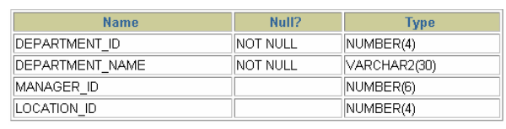

**Answer:**

DESCRIBE departments

SELECT *

FROM departments;

7. You need to determine the structure of the EMPLOYEES table.

**Answer:**

DESCRIBE employees

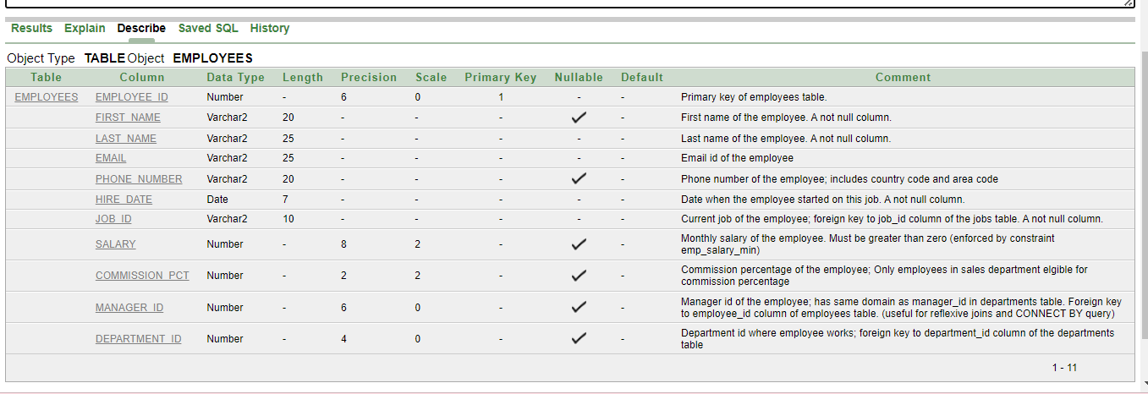

SELECT employee_id, last_name, job_id, hire_date StartDate

FROM employees;

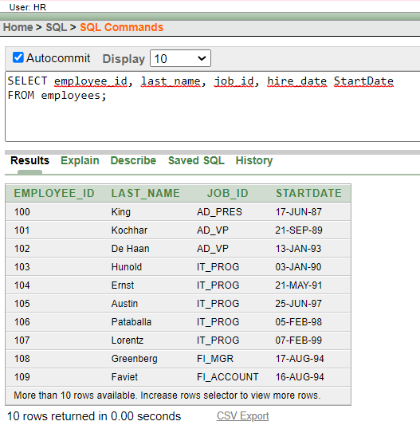

8. Test your query in the file lab_01_07.sql to ensure that it runs correctly.

SELECT employee_id, last_name, job_id, hire_date StartDate

FROM employees;



9. The HR department needs a query to display all unique job codes from the EMPLOYEES

table.

SELECT DISTINCT job_id

FROM employees;

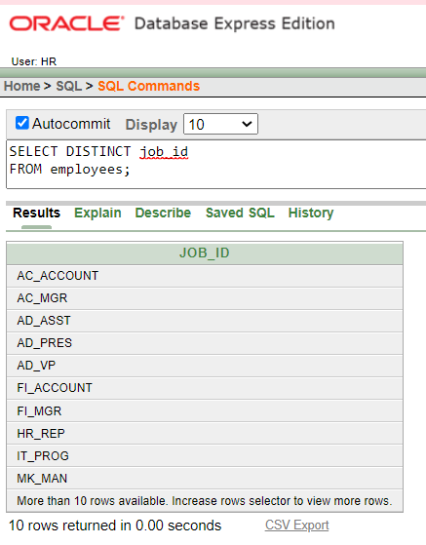

10. The HR department wants more descriptive column headings for its report on employees.

Copy the statement from lab_01_07.sql to the iSQL*Plus Edit window. Name the

column headings Emp #, Employee, Job, and Hire Date, respectively. Then run your

query again.

SELECT employee_id "Emp #", last_name "Employee",

job_id "Job", hire_date "Hire Date"

FROM employees;

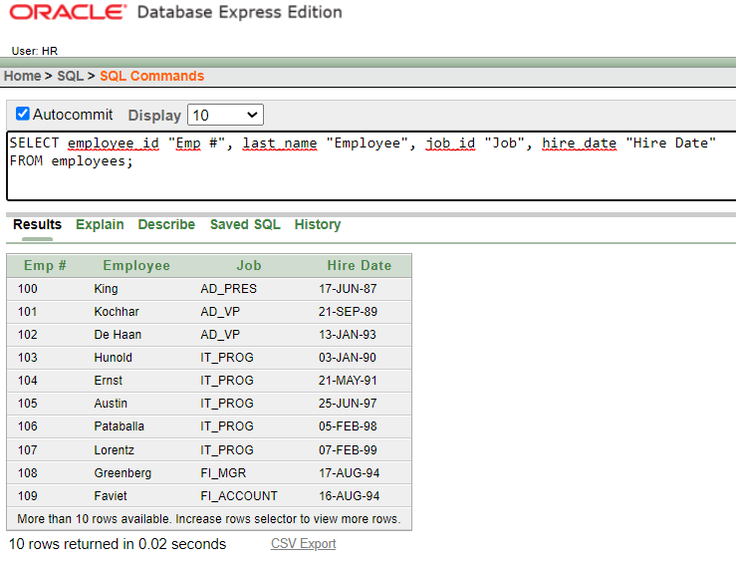

11. The HR department has requested a report of all employees and their job IDs. Display the

last name concatenated with the job ID (separated by a comma and space) and name the

column Employee and Title.

SELECT last_name||', '||job_id AS "Employee and Title"

FROM employees;

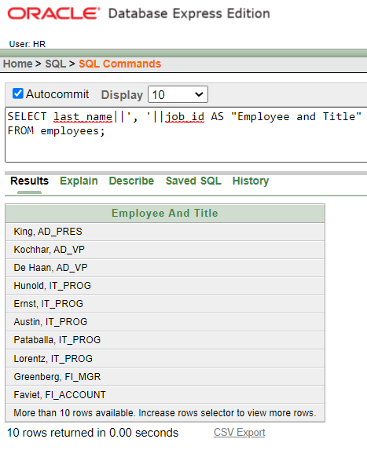

12. To familiarize yourself with the data in the EMPLOYEES table, create a query to display all

the data from the EMPLOYEES table. Separate each column output by a comma. Name the

column title THE_OUTPUT.

SELECT employee_id || ',' || first_name || ',' || last_name || ',' || email || ',' || phone_number || ','|| job_id

|| ',' || manager_id || ',' || hire_date || ',' || salary || ',' || commission_pct || ',' || department_id

AS THE_OUTPUT

FROM employees;

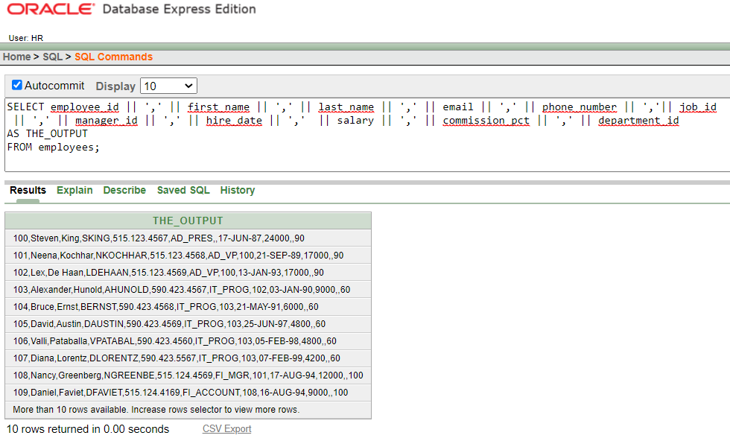

Submitted by-

**MD. SOROWAR MAHABUB RABBY**

Matric ID: **C201032**, Section: 3**AM**

Department of CSE (Computer Science and Engineering)